Sistemas Informáticos (Computer Systems)  
Unit 03. Activities 02. Solution

short line

Authors: Sergi García, Alfredo Oltra

Updated October 2023

Unit 03. Activities 02- Solution

# Exercise 01

**Solution FCFS**

**FCFS table:**

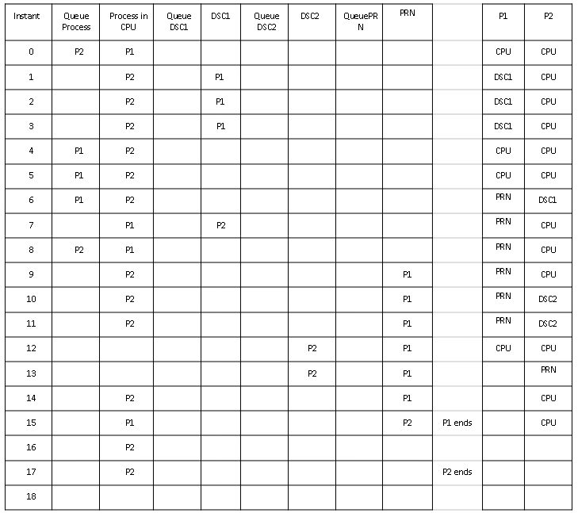

**FCFS final values:**

* **P1 Return time**: 16
* **P2 Return time:** 18
* **Mean return time:** 17
* **P1 queue waiting time:** 3
* **P2 queue waiting time:** 2
* **CPU usage**: 16/18= 88%

**Solution Round Robin**

Since the proposed activity is a little different, we will propose the solution (only a few steps).

To solve it, we will use the table on the next page, where for each moment of time we will write down where each process is located.

* At instant 0 both processes want to use the CPU, but only one can do it. Then P1 uses the CPU while P2 remains in the queue.
* At instant 1 the quantum ends so the P2 starts using the CPU. At that instant, the P1 needs to use disk1. As he is free, P1 uses it.
* At instant 2 the quantum ends so the P2 has to go out of the CPU. But the CPU queue is empty, because P1 continues working with the disc1, so another quantum is given to P2.

Can you continue? ;)

**Round Robin table:**

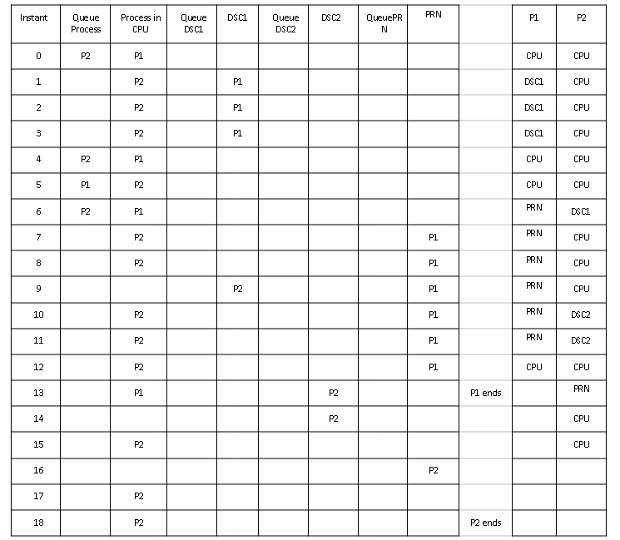

**Round Robin final values:**

* **P1 Return time:** 14
* **P2 Return time:** 19
* **Mean return time:** 16.5
* **P1 queue waiting time:** 1
* **P2 queue waiting time:** 3
* **CPU usage:** 16/19= 84%